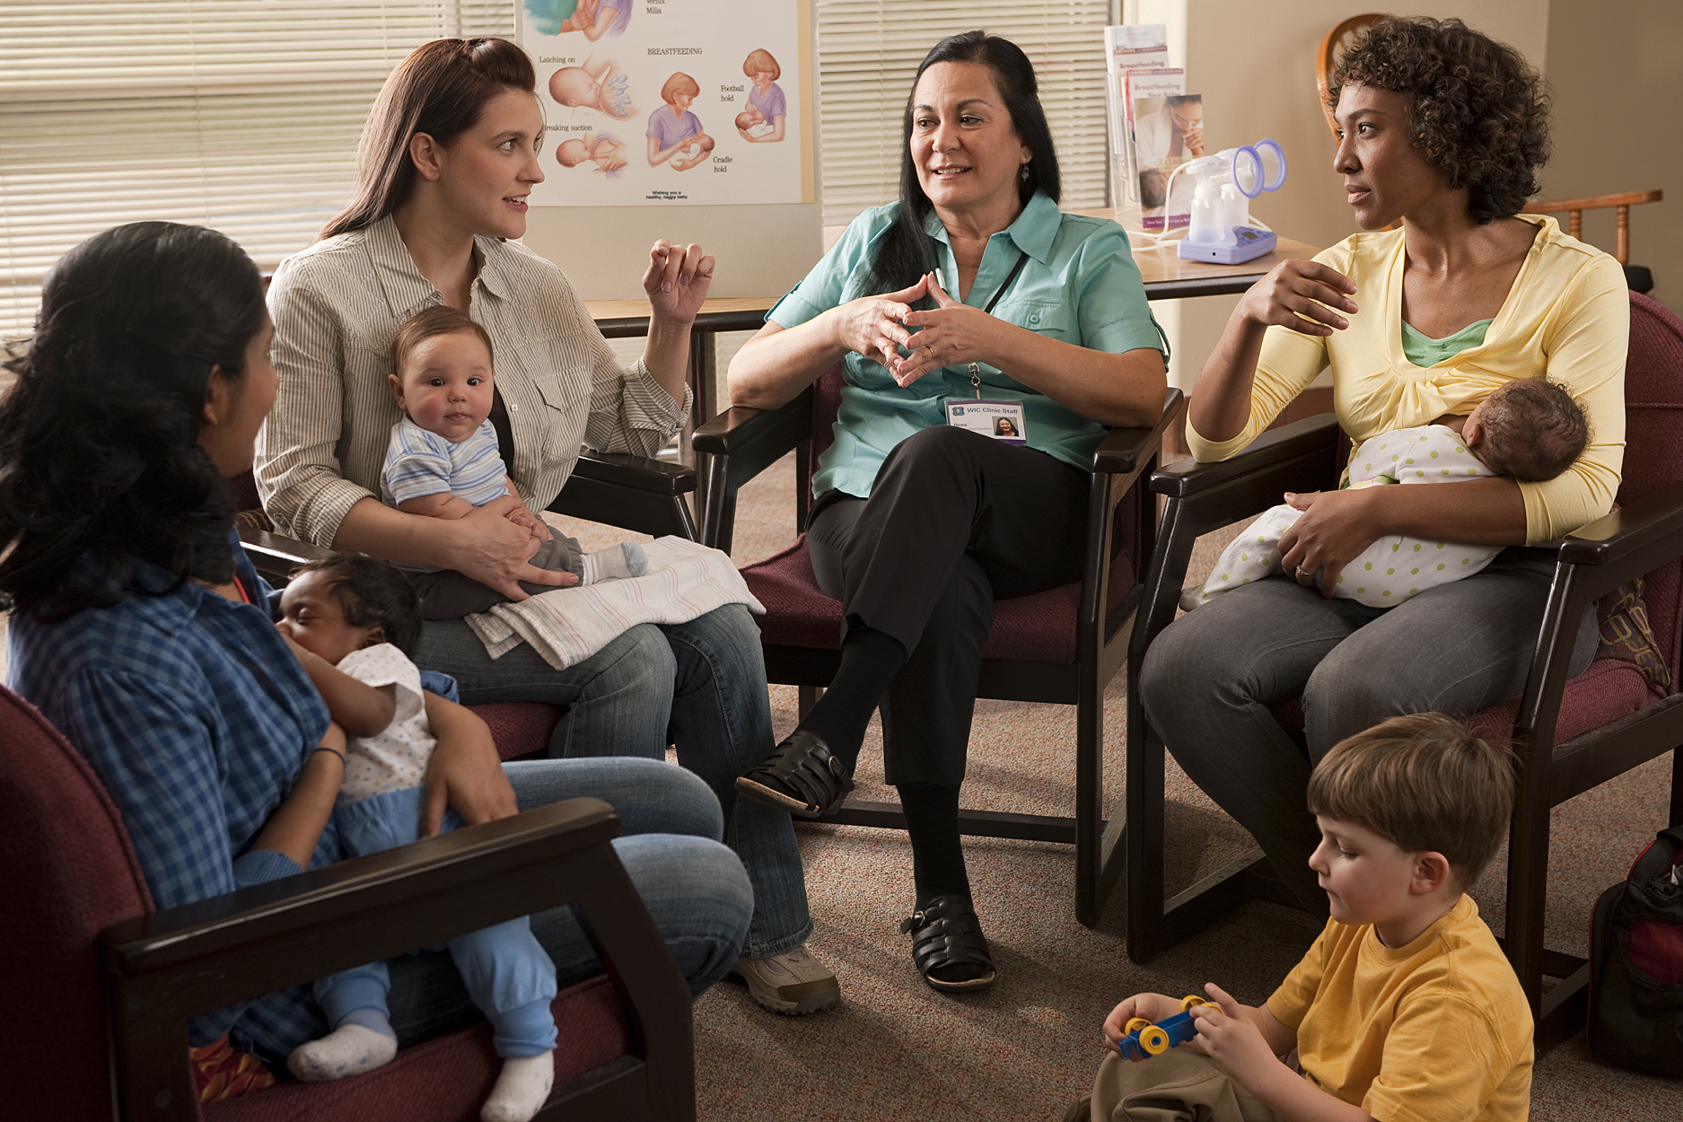  Free mom & baby group  rEGENCY Park Library  Tuesdays 6:00-7:30pm  9701 Little Rd.  New Port Richey, FL 34654  For more information call:  813-345-3307  cOME JOIN US! THIS IS A GREAT CHANCE TO RELAX AND CONNECT WITH OTHER MOTHERS  THE GROUP WILL PROVIde free breastfeeding support and mothering support. Children are welcome!  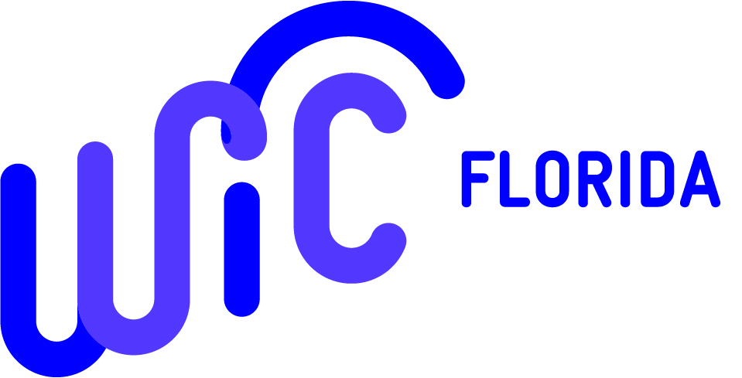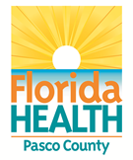  This institution is an equal opportunity provider. | Learn more about:  Breastfeeding Basics  Returning to Work/School  Pumping Tips  Latching & Milk Supply Questions  Infant Feeding & Nutrition  Newborn Comfort  Pasco’s Breast Friends (Group)*  Hernando’s Breast Friends (Group)*  *These groups are not affiliated with FL DOH or WIC

