Volunteer Application – The Big Latch On Event

Volunteer Information
Name
Home Phone
Organization
Cell Phone
E-Mail Address
Explain if you have had any prior safety education experience.
Will you need community service hours?

Person to Notify in Case of Emergency
Name
Street Address
City, ST, ZIP Code
Home Phone
Cell Phone
E-Mail Address

Agreement and Signature

I agree to participate in the Big Latch On event, to report on time and remain at the event the agreed upon length of time.
Name (printed)
Signature
Date
Authorized Representative (for minor)

Thank you for completing this application form and for your interest in volunteering with us.
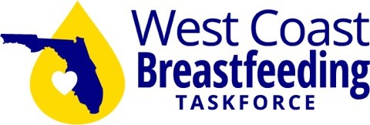
For more information contact
The Florida West Coast Breastfeeding Task Force
flwcbreastfeeding@gmail.com

